
Developer Guide:

Supervisor. | Miss Esha Shahid
Batch. | 2507G1
Group. | B
Serial No. | Enrollment Number | Student Name
1. | Student1674403 | Muhammad ahad shah
2. | Student1674467 | Muhammad umair
3. | Student1674875 | Muhammad aqib
4. | Student1673155 | Muhammad umar farooq

THE CAKE:

- INTRODUCTION:

Where every celebration begins with a masterpiece. We craft
exquisite, handcrafted cakes using the finest ingredients,
blending timeless baking traditions with modern elegance.
Whether it’s a birthday, wedding, anniversary, or any special
moment, our premium creations are designed to enchant
your taste buds and create unforgettable memories

Screenshots:

- Home (cake(1).html)

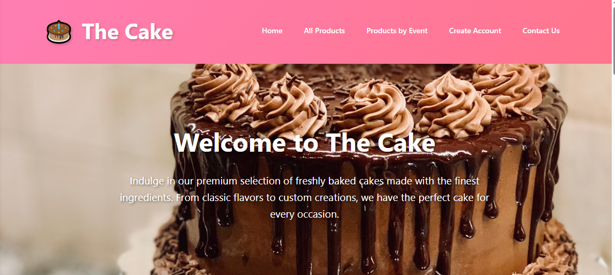

Figure 1: Home page to The Cake
 Our Slogan has given to the peoples toward our website. “ENJOY YOUR HAPPINESS WITH US”.
- Welcome to The Cake Page we are here for help you.

Code of Home page:
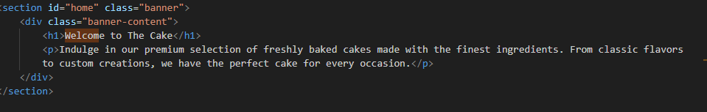

Navbar .
Figure 2: Navbar
We have given six essentials. By clicking any of the essential’s and redirect to the linked page.

Code of Navbar
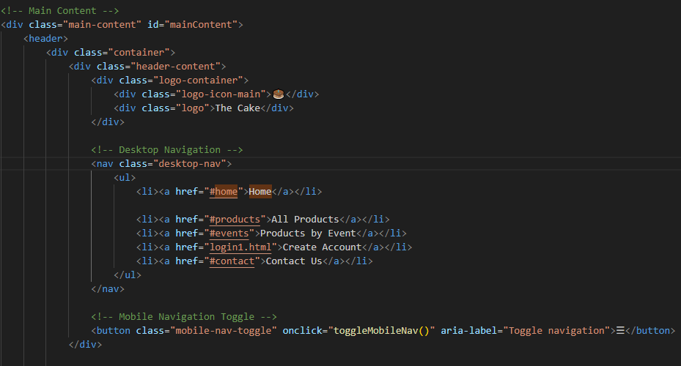

- About us

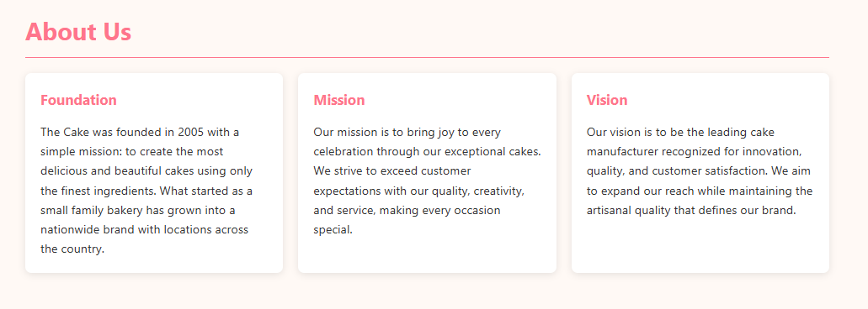

Figure 3: About us
Explore different cakes, from our website for your happiness
Discover all about our Foundation , Mission and our vision.
We all welcome you in our family
Code of About Us:

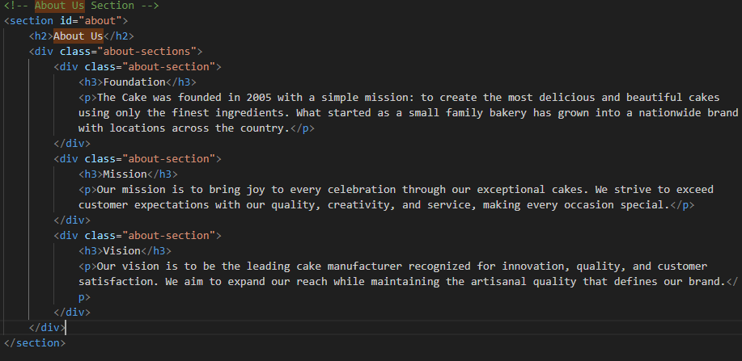

Figure 4: Visit
if you want to visit our shop you can find our addres on our pages.
We have warm welcome you in our website

OUR LOCATION:

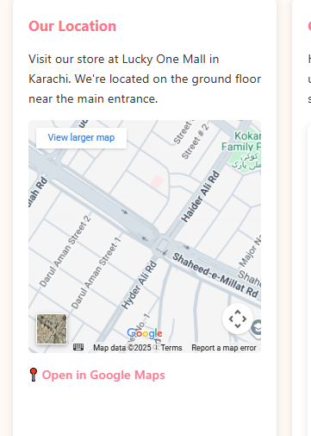

Code of visit:
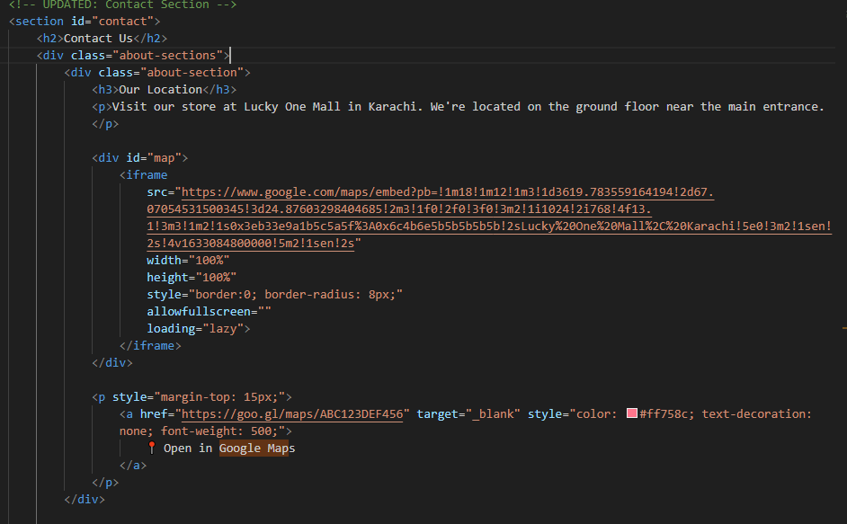

STORE ADDRESS, TIMING, SOCIAL MEDIA:
The Cake" is located at Lucky One Mall, Karachi, and remains open six days a week.You can reach out via phone, email, or stay connected through social media.Follow them online for updates, promotions, and sweet cake inspirations!

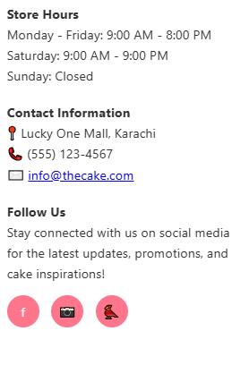

Code of store hour:
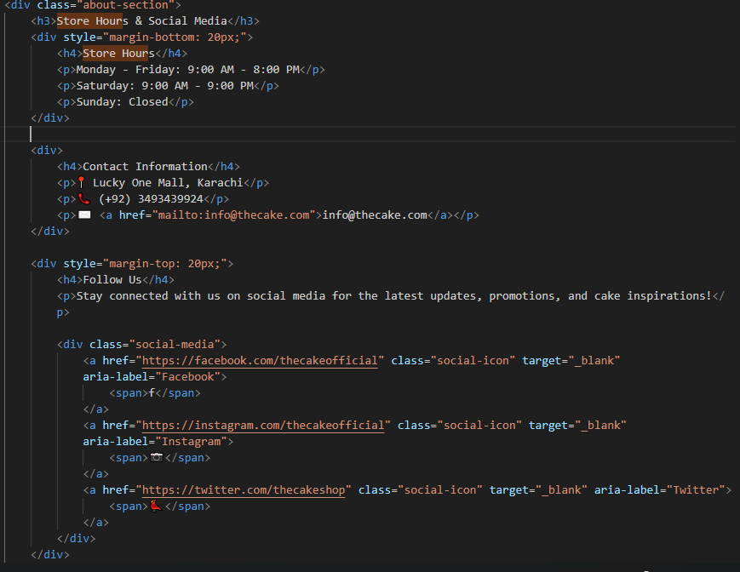

Figure 5: how to order

Please complete all required fields in the form below. Double-check your contact and delivery details before submitting. Once your order is placed, you’ll receive a confirmation email with your order summary and estimated delivery time.
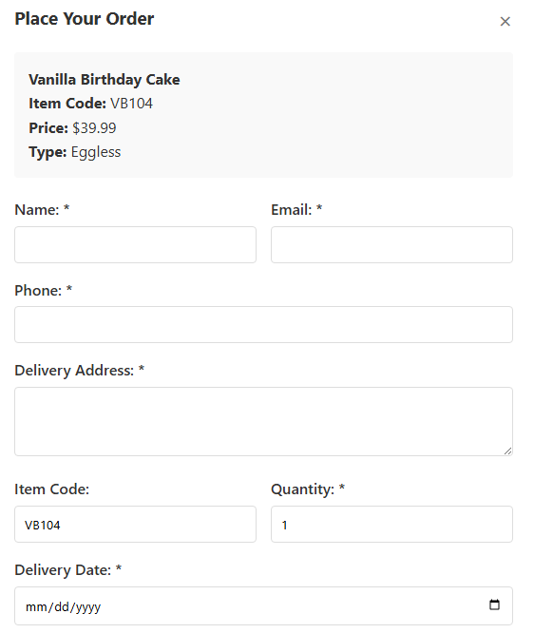

Code of Contact:
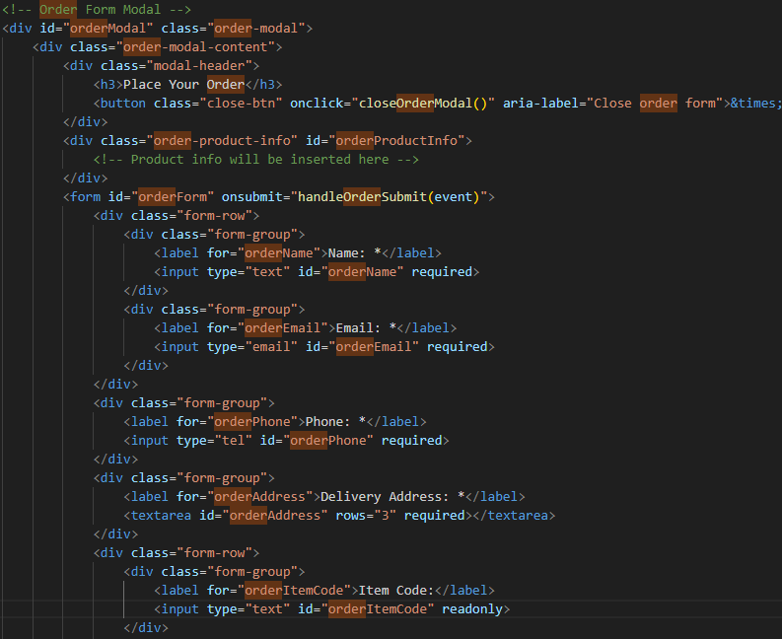

6.Contact US ):
Figure 6: Contact
WE ALREADY PUT OUR LOCATION AND TIMING ETC ON *(4) FIGURE AND ANY KIND OF QUERY YOU CAN CONTACT US ON OUR WEBSITE HAVE NICE JOURNEY
THANK YOU
Feedback Form:
FOR FEEDBACK FORM OF CUSTOMER WE ARE WORKING ON IT

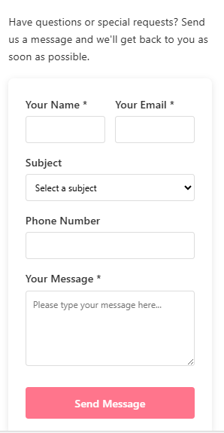

Code of Contact:
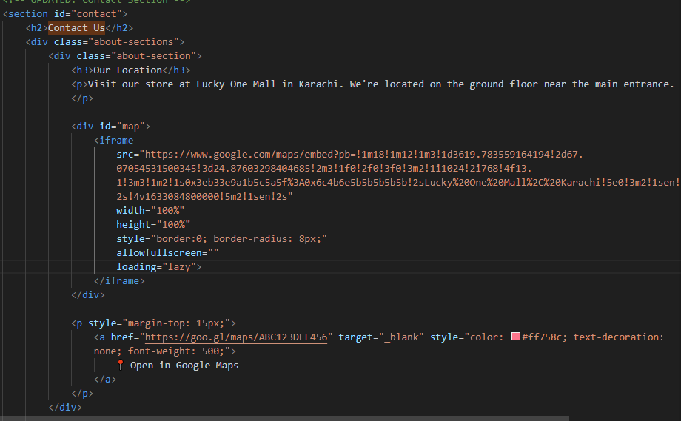

7 FOOTER :

IN OUR WEBSITE YOU WILL SEARCH FOR MANY CAKE OUR WEBSITE IS FULLY OFFICIAL AND LEGAL AND THIER SOMETHING FOR ABOUT OUR CAKE I WISH YOU YOU WILL ENJOY OUR DEAL AND FOOD.
THANK YOU!

Figure 7: Footer

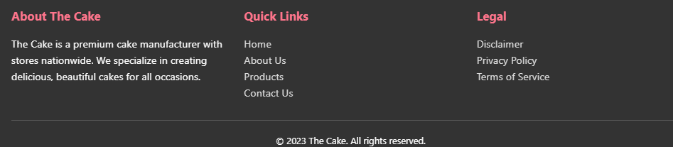

Code of Footer:

